**BOOKLET 3**

**SCIENCE DEPARTMENT**

**YEAR 11**

**HUMAN BIOLOGICAL SCIENCE EXAMINATION**

**SEMESTER 1, 2011**

**Student Name:** ______________________________________ **Form:** _______________

**Teacher Name:** ______________________________________

**Time allowed for this paper**

Reading time before commencing work: 10 minutes

Working time for paper: 2.5 hours

**Materials required / recommended for this paper**

To be provided by the supervisor

**Booklet 1** – Multiple Choice Question Booklet

**Booklet 2** – Multiple Choice Answer Sheet and Extended Answer Lined Paper

**Booklet 3** – Short Answer Questions and Extended Answer Questions

To be provided by the candidate

*Standard items:* Pens, pencils, eraser or correction fluid, ruler

*Special items:* A 2B, B or HB pencil for the separate Multiple Choice Answer Sheet and calculators satisfying the conditions set by the Curriculum Council for this subject.

*(Graphics type calculators are* ***NOT*** *permitted)*

**Important note to candidates**

No other items may be taken into the examination room. It is **your** responsibility to ensure that you do not have any unauthorised notes or other items of a non-personal nature in the examination room. If you have any unauthorised material with you, hand it to the supervisor **before** reading any further.

**Structure of this paper**

|  |  |  |  |
| --- | --- | --- | --- |
| **Section** | **Number of questions available** | **Number of questions to be attempted** | **Percentage of Total Score** |
| A Multiple Choice | 40 | 40 | /40 |
| B Short Answer questions | 20 | 20 | /40 |
| C Extended Answer questions: | 4 | 2 | /20 |
|  |  | **Total %** | **/100** |

**Instructions to candidates**

1. Answer the questions according to the following instructions.

**Section A** Answer ALL multiple choice questions by crossing out the letter of your choice on the Answer Sheet provided. Use 2B pencil here.

**Section B** Answer the questions in the spaces provided. Answers to be in BLUE or BLACK biro. GRAPHS and DRAWINGS to be in pencil.

**Section C** Answer BOTH questions in this section.

Write your answers on the lined paper provided.

2. You should note that the space made available for an answer is not necessarily an indication of the length of the answer.

3. You must not take any of the examination booklets away from the examination room.

|  |  |  |  |  |
| --- | --- | --- | --- | --- |
|  |  |  |  |  |

**SECTION B SHORT ANSWER QUESTIONS (104 marks)**

Answer Questions 41 – 50 by selecting the most appropriate biological term for each question. **DO NOT** use abbreviations.

1. Type of transport where materials are transported with the diffusion gradient.

_________________________________________

1. The wave of constriction in the oesophagus to push food along.

_________________________________________

1. The nutrient group that contains carbon, hydrogen, oxygen and nitrogen.

_________________________________________

44. The conical teeth used for tearing.

_________________________________________

1. An organic catalyst that speeds up the rate of reactions.

_________________________________________

46. Chemical molecule that takes the protein code instructions from the nucleus to the ribosomes.

_________________________________________

1. Structures in the cell that are responsible for spindle formation.

_________________________________________

1. A term describing a tentative proposal to explain certain observations.

_________________________________________

1. The molecule upon which the enzyme acts.

_________________________________________

1. The term for homologous pairs of chromosomes breaking and exchanging segments.

_________________________________________

(10 marks)

**Question 51** (Total 15 marks)

a) Diagram of a human cell. Name the cell structures represented by labels A-H.

(holes)

Glycogen granules

Nucleus

Vacuoles forming

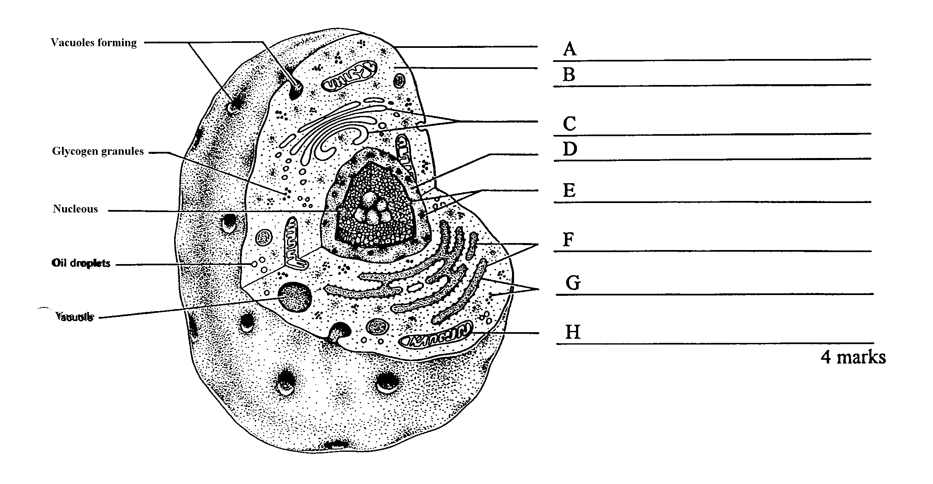

Vacules

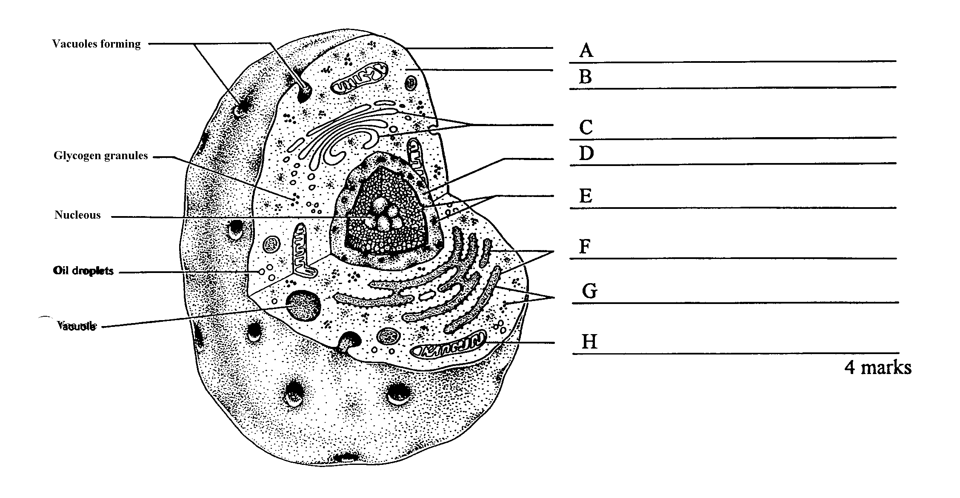

(dot)

b) In the diagram above, what is the function of:

(8 marks)

(dots)

Vacuole

Oil droplet

Structure A ______________________________________________________________

Structure H ______________________________________________________________

(2 marks)

c) (i) If this was a hard working muscle cell, name the immediate source of energy it would use.

_____________________________________________________________(1 mark)

(ii) How is this molecule changed to allow the release of energy for use in muscle contraction?

_____________________________________________________________(1 mark)

(iii) Explain how DNA can control protein production when it never leaves the nucleus.

__________________________________________________________________________________________________________________________________________________________________________________________________________________________________________________________________________________________________________________________________________________________________________________________________________________________________________________________________________________________________________

(3 marks)

**Question 52** (Total 5 marks)

The following diagrams show different stages of the mitotic division of one cell.

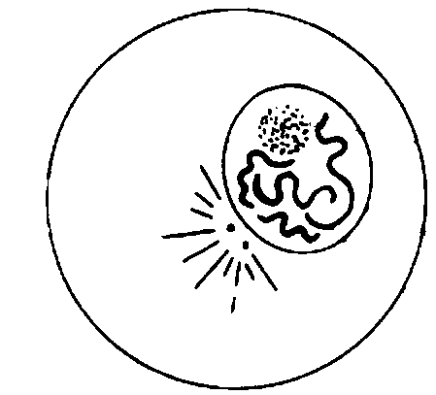

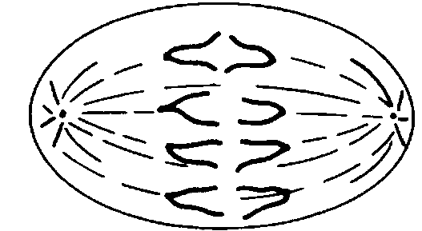

A

**B**

**C**

**D**

**E**

**F**

**G**

**H**

**I**

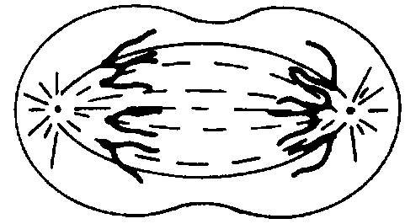

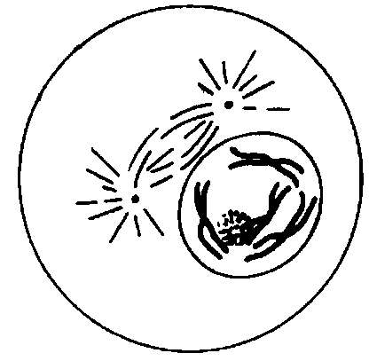

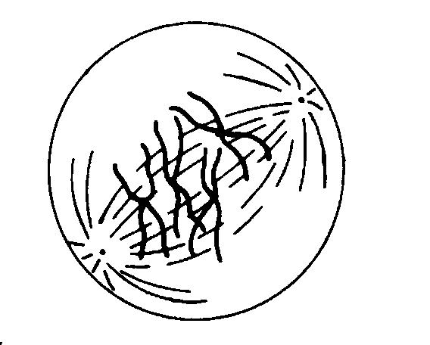

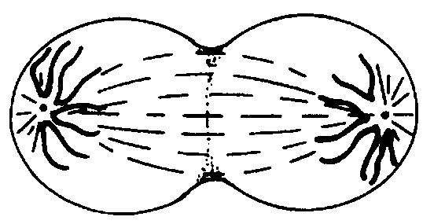

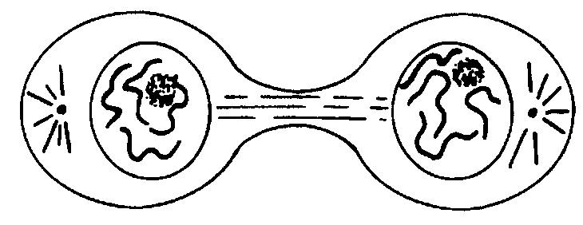

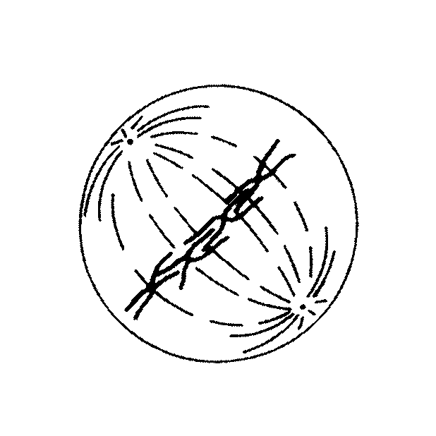

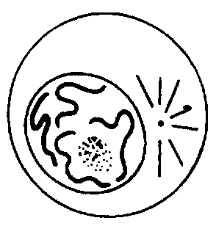

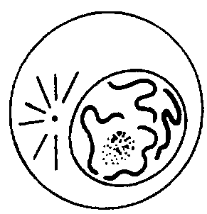

a)

|  |  |
| --- | --- |
| Stage | Briefly describe what is happening in the cell at this stage |
| C |  |
| D |  |
| E |  |

(3 marks)

(b) Using the letters A- I, identify when the cell is at the stage of mitosis called:

(i) Early Telophase __________ (ii) Prophase ____________ (2 marks)

**Question 53** (Total 12 marks)

Use the diagram of the heart to match the appropriate number in the table below.

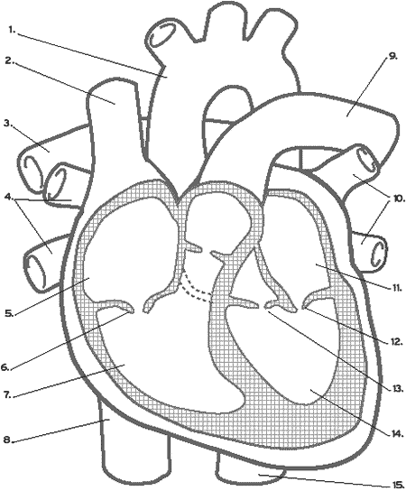

|  |  |
| --- | --- |
|  | Returns deoxygenated blood back to the heart. |
|  | Prevents blood from flowing back into the right atrium. |
|  | Blood is directed to the left lung though this structure. |
|  | Prevents atrioventricular valve from turning inside out. |
|  | Ensures that blood does not flow back into the ventricles. |
|  | Brings oxygenated blood back to the heart. |

(6 marks)

1. Use **large arrows** to clearly indicate the direction of flow of OXYGENATED blood through the heart and its vessels. (1 mark)
2. What are the differences between the pulmonary and the systemic circulations?

_____________________________________________________________________________ _____________________________________________________________________________

_____________________________________________________________________________

(2 marks)

d) Explain the following terms:

1. Arteriosclerosis

_____________________________________________________________________

_____________________________________________________________________

_____________________________________________________________________

(ii) Atherosclerosis ____________________________________________________________________

_____________________________________________________________________

_____________________________________________________________________

(iii) Myocardial Infarction

_____________________________________________________________________

_____________________________________________________________________

_____________________________________________________________________

(3 marks)

**Question 54** (Total 10 marks)

The heart walls contain muscle cells that are able to contract.

a) Name the type of muscle cells. ______________________________________ (1 mark)

b) Name the type of organelle found in the cells that is directly responsible for the release of energy for the activity of these cells.

__________________________________________________________________ (1 mark)

c) A cell was observed under a microscope that had two ocular lenses as well as 5x, 20x and 60x objectives. Fill in the missing spaces to complete this table:

|  |  |  |  |
| --- | --- | --- | --- |
| Ocular | Objective | Magnification | Field of view |
| 10x | 5x | 50 |  |
| 15x | 20x | 300 | 300 micrometers |
| 15x | 60x | 900 |  |

(2 marks)

d) If the cell was 0.0l mm wide, how wide would it be in micrometres?

__________________________________________________________________ (1 mark)

e) Using the diagram below, explain what is happening in parts A to C.

_____________________________________________________________________________

_____________________________________________________________________________

_____________________________________________________________________________

_____________________________________________________________________________

_____________________________________________________________________________

_____________________________________________________________________________

____________________________________________________________________________

(3 marks)

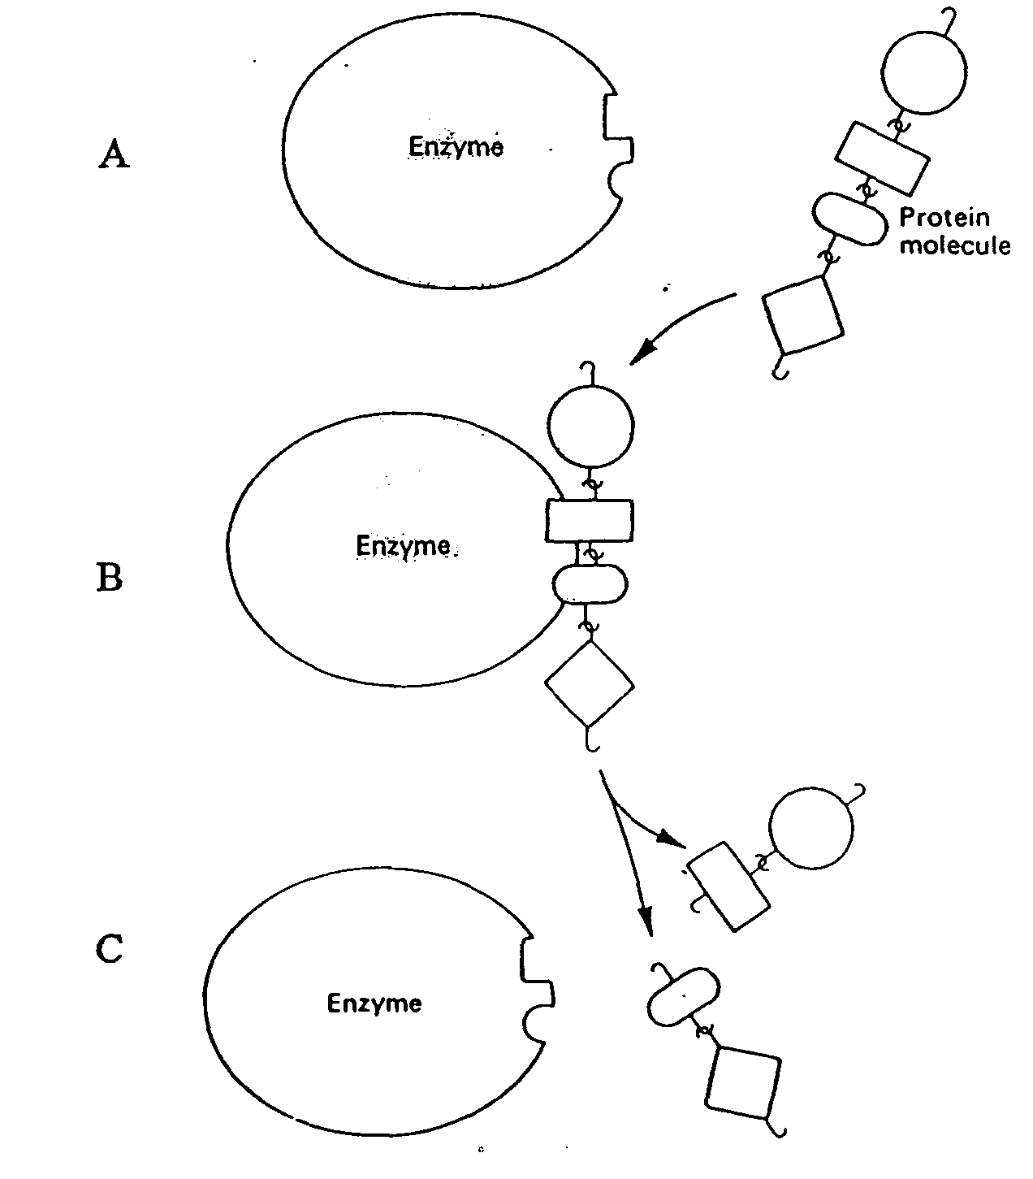

Enzyme

Enzyme

Enzyme

Protein molecule

f) There are a number of factors that might affect the speed of this reaction.

List any two:

i.

ii.

(2 mark)

**Question 55** (Total 8 marks)

The diagram below shows the passage of red blood cells through a capillary in muscle tissue. Use this diagram to answer questions (a) and (b).

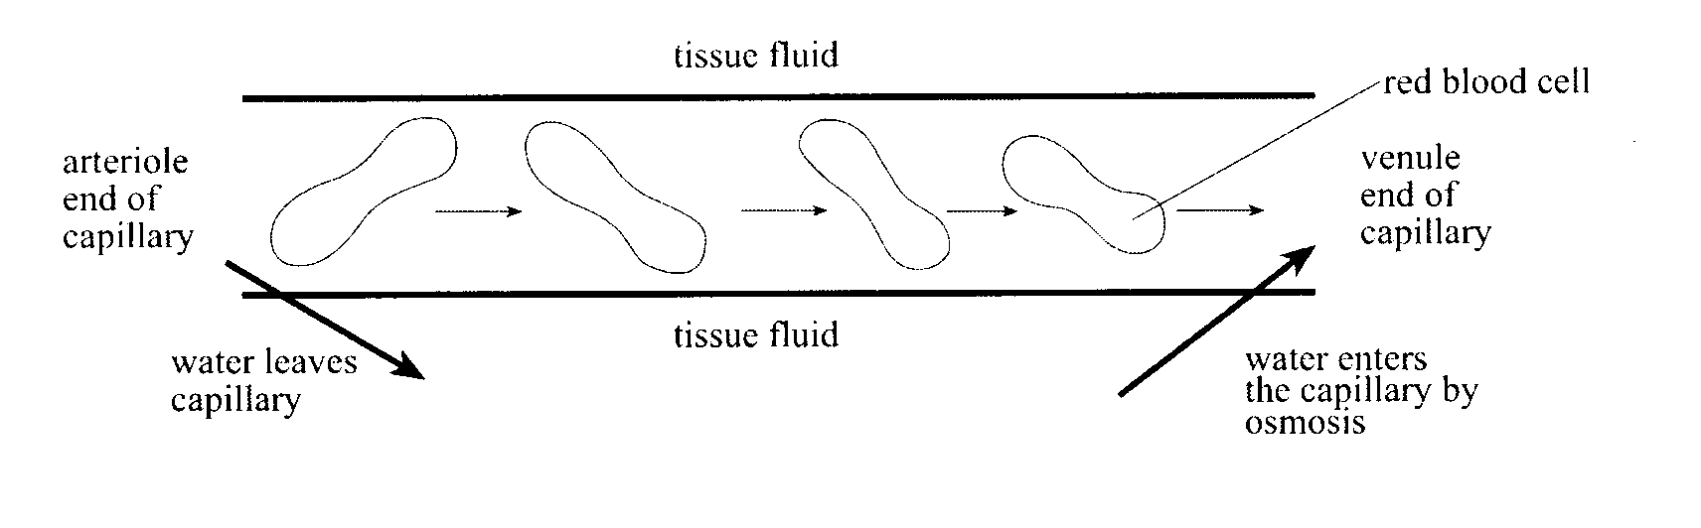

1. Explain why water enters the capillary at the venule end by osmosis.

_________________________________________________________________________________________________________________________________________________________________________________________________________________________________________________________________________________________________________________________________________________________________________________________________

(2 marks)

1. Describe **TWO** ways in which the composition of the blood at the arteriole end of the capillary differs from the composition of the blood at the venule end of the capillary.

_________________________________________________________________________________________________________________________________________________________________________________________________________________________________________________________________________________________________________________________________________________________________________________________________

(4 marks)

1. What structures are found in the blood but NOT in the interstitial fluid?

_________________________________________________________________________________________________________________________________________________________________________________________________________________________________________________________________________________________________________________________________________________________________________________________________

(2 marks)

**Question 56** (Total 9 marks)

The diagram below refers to parts (a) to (d) of Question 56.

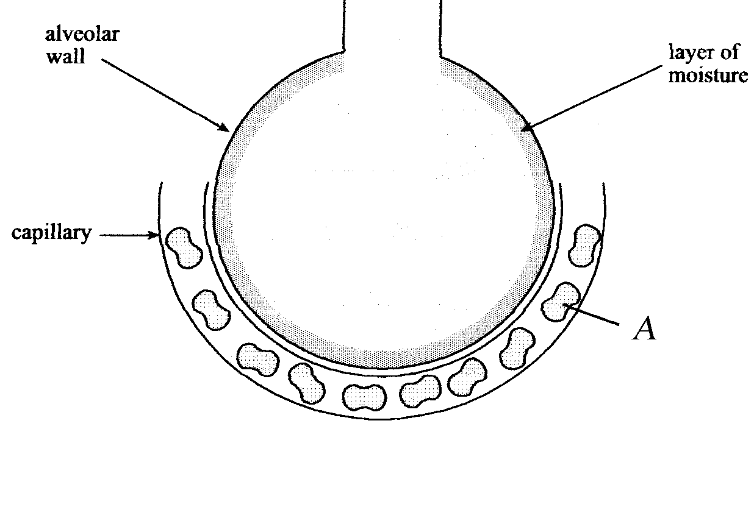

1. State **ONE** function of the layer of moisture that lines the alveolar wall.

_______________________________________________________________________________________________________________________________________________________________________________________________________________________________________

(1 mark)

(i) Name **ONE** other structural feature of the alveolar wall tissue.

______________________________________________________________________

(1 mark)

(1)

(ii) State **ONE** way in which the structural feature you listed in the question above facilities efficient gas exchange.

__________________________________________________________________________________________________________________________________________________________________________________________________________________

(1 mark)

c)

(i) Name the structure labelled A.

______________________________________________________________________

(1 mark)

(ii) What role does it perform in the gas exchange in the lungs?

________________________________________________________________________________________________________________________________________________________________________________________________________________________________________________________________________________________

(2 marks)

1. Complete the following table by describing how the following respiratory system components, or actions assist in normal lung function.

|  |  |
| --- | --- |
| **Component of the Respiratory System** | **Function** |
| Cilia |  |
| Mucus Secretion |  |
| Coughing |  |

(3 marks)

**Question 57** (Total 6 marks)

It is possible to dissolve and remove the outer hard shell of a hen’s egg using acid. This process leaves the cell membrane undamaged and the egg contents intact. Shells were removed in this way from three eggs and each egg was placed in one of three different solutions:

Solution 1: Distilled water

Solution 2: A dilute sugar solution

Solution 3: A concentrated sugar solution

The weight of the eggs was recorded at regular time intervals over 24 hours. The results are presented below:

a) Describe and explain how the weight of the egg in **Solution 1** changed over time.

________________________________________________________________________________________________________________________________________________________________________________________________________________________________________________________________________________________

(3 marks)

1. Describe and explain how the weight of the egg in **Solution 3** changed over time.

____________________________________________________________________________________________________________________________________________________________________________________________________________________________________________________________________________________________________________________

(3 marks)

**Question 58** (Total 10 marks)

(a) Complete the following paragraph on the respiratory system:

The pharynx is located at the back of the nose and mouth and is a common passage for both _________________ and _____________________. The larynx is located at the beginning of the ______________________ and contains the _________________. The _________________ is a specialised flap of skin that forms part of the larynx. Its job is to prevent any food or water from entering the trachea or windpipe during the act of _______________________. This means that breathing is briefly interrupted.

(3 marks)

(b) Explain with the aid of a diagram how gases are transported around the body to keep cells alive.

_____________________________________________________________________________ _____________________________________________________________________________ _____________________________________________________________________________ _____________________________________________________________________________ _____________________________________________________________________________ _____________________________________________________________________________ _____________________________________________________________________________ _____________________________________________________________________________

(5 marks)

(c) In Expired Air Resuscitation, the air from the rescuer’s lungs are used to keep the subject alive. Explain how this is possible.

_____________________________________________________________________________ _____________________________________________________________________________ _____________________________________________________________________________ _____________________________________________________________________________ _____________________________________________________________________________ _____________________________________________________________________________ _____________________________________________________________________________

(2 marks)

**Question 59** (Total 12 marks)

In an experiment, ten test tubes containing digestive enzyme and its substrate were placed in a water bath at 370C. Each test tube had a different pH (acidity) value between 1 and 10. The reaction was stopped after a given time and the amount of product formed was measured. From the results, enzyme activities at pH values between 1 and 10 were calculated and are shown in the table below.

**Table 8: Enzyme Activity at Difference pH Values**

|  |  |
| --- | --- |
| **pH** | **Enzyme Activity (International Units)** |
| 1 | 8 |
| 2 | 10 |
| 3 | 15 |
| 4 | 28 |
| 5 | 35 |
| 6 | 77 |
| 7 | 90 |
| 8 | 110 |
| 9 | 76 |
| 10 | 24 |

1. Plot a line graph to display this data on **the next page**.

|  |  |  |  |  |  |  |  |  |  |  |  |  |  |  |  |  |  |  |  |  |  |  |  |  |  |  |  |  |  |  |  |  |  |  |  |  |  |  |  |
| --- | --- | --- | --- | --- | --- | --- | --- | --- | --- | --- | --- | --- | --- | --- | --- | --- | --- | --- | --- | --- | --- | --- | --- | --- | --- | --- | --- | --- | --- | --- | --- | --- | --- | --- | --- | --- | --- | --- | --- |
|  |  |  |  |  |  |  |  |  |  |  |  |  |  |  |  |  |  |  |  |  |  |  |  |  |  |  |  |  |  |  |  |  |  |  |  |  |  |  |  |
|  |  |  |  |  |  |  |  |  |  |  |  |  |  |  |  |  |  |  |  |  |  |  |  |  |  |  |  |  |  |  |  |  |  |  |  |  |  |  |  |
|  |  |  |  |  |  |  |  |  |  |  |  |  |  |  |  |  |  |  |  |  |  |  |  |  |  |  |  |  |  |  |  |  |  |  |  |  |  |  |  |
|  |  |  |  |  |  |  |  |  |  |  |  |  |  |  |  |  |  |  |  |  |  |  |  |  |  |  |  |  |  |  |  |  |  |  |  |  |  |  |  |
|  |  |  |  |  |  |  |  |  |  |  |  |  |  |  |  |  |  |  |  |  |  |  |  |  |  |  |  |  |  |  |  |  |  |  |  |  |  |  |  |
|  |  |  |  |  |  |  |  |  |  |  |  |  |  |  |  |  |  |  |  |  |  |  |  |  |  |  |  |  |  |  |  |  |  |  |  |  |  |  |  |
|  |  |  |  |  |  |  |  |  |  |  |  |  |  |  |  |  |  |  |  |  |  |  |  |  |  |  |  |  |  |  |  |  |  |  |  |  |  |  |  |
|  |  |  |  |  |  |  |  |  |  |  |  |  |  |  |  |  |  |  |  |  |  |  |  |  |  |  |  |  |  |  |  |  |  |  |  |  |  |  |  |
|  |  |  |  |  |  |  |  |  |  |  |  |  |  |  |  |  |  |  |  |  |  |  |  |  |  |  |  |  |  |  |  |  |  |  |  |  |  |  |  |
|  |  |  |  |  |  |  |  |  |  |  |  |  |  |  |  |  |  |  |  |  |  |  |  |  |  |  |  |  |  |  |  |  |  |  |  |  |  |  |  |
|  |  |  |  |  |  |  |  |  |  |  |  |  |  |  |  |  |  |  |  |  |  |  |  |  |  |  |  |  |  |  |  |  |  |  |  |  |  |  |  |
|  |  |  |  |  |  |  |  |  |  |  |  |  |  |  |  |  |  |  |  |  |  |  |  |  |  |  |  |  |  |  |  |  |  |  |  |  |  |  |  |
|  |  |  |  |  |  |  |  |  |  |  |  |  |  |  |  |  |  |  |  |  |  |  |  |  |  |  |  |  |  |  |  |  |  |  |  |  |  |  |  |
|  |  |  |  |  |  |  |  |  |  |  |  |  |  |  |  |  |  |  |  |  |  |  |  |  |  |  |  |  |  |  |  |  |  |  |  |  |  |  |  |
|  |  |  |  |  |  |  |  |  |  |  |  |  |  |  |  |  |  |  |  |  |  |  |  |  |  |  |  |  |  |  |  |  |  |  |  |  |  |  |  |
|  |  |  |  |  |  |  |  |  |  |  |  |  |  |  |  |  |  |  |  |  |  |  |  |  |  |  |  |  |  |  |  |  |  |  |  |  |  |  |  |
|  |  |  |  |  |  |  |  |  |  |  |  |  |  |  |  |  |  |  |  |  |  |  |  |  |  |  |  |  |  |  |  |  |  |  |  |  |  |  |  |
|  |  |  |  |  |  |  |  |  |  |  |  |  |  |  |  |  |  |  |  |  |  |  |  |  |  |  |  |  |  |  |  |  |  |  |  |  |  |  |  |
|  |  |  |  |  |  |  |  |  |  |  |  |  |  |  |  |  |  |  |  |  |  |  |  |  |  |  |  |  |  |  |  |  |  |  |  |  |  |  |  |
|  |  |  |  |  |  |  |  |  |  |  |  |  |  |  |  |  |  |  |  |  |  |  |  |  |  |  |  |  |  |  |  |  |  |  |  |  |  |  |  |
|  |  |  |  |  |  |  |  |  |  |  |  |  |  |  |  |  |  |  |  |  |  |  |  |  |  |  |  |  |  |  |  |  |  |  |  |  |  |  |  |
|  |  |  |  |  |  |  |  |  |  |  |  |  |  |  |  |  |  |  |  |  |  |  |  |  |  |  |  |  |  |  |  |  |  |  |  |  |  |  |  |
|  |  |  |  |  |  |  |  |  |  |  |  |  |  |  |  |  |  |  |  |  |  |  |  |  |  |  |  |  |  |  |  |  |  |  |  |  |  |  |  |
|  |  |  |  |  |  |  |  |  |  |  |  |  |  |  |  |  |  |  |  |  |  |  |  |  |  |  |  |  |  |  |  |  |  |  |  |  |  |  |  |
|  |  |  |  |  |  |  |  |  |  |  |  |  |  |  |  |  |  |  |  |  |  |  |  |  |  |  |  |  |  |  |  |  |  |  |  |  |  |  |  |
|  |  |  |  |  |  |  |  |  |  |  |  |  |  |  |  |  |  |  |  |  |  |  |  |  |  |  |  |  |  |  |  |  |  |  |  |  |  |  |  |
|  |  |  |  |  |  |  |  |  |  |  |  |  |  |  |  |  |  |  |  |  |  |  |  |  |  |  |  |  |  |  |  |  |  |  |  |  |  |  |  |
|  |  |  |  |  |  |  |  |  |  |  |  |  |  |  |  |  |  |  |  |  |  |  |  |  |  |  |  |  |  |  |  |  |  |  |  |  |  |  |  |
|  |  |  |  |  |  |  |  |  |  |  |  |  |  |  |  |  |  |  |  |  |  |  |  |  |  |  |  |  |  |  |  |  |  |  |  |  |  |  |  |
|  |  |  |  |  |  |  |  |  |  |  |  |  |  |  |  |  |  |  |  |  |  |  |  |  |  |  |  |  |  |  |  |  |  |  |  |  |  |  |  |
|  |  |  |  |  |  |  |  |  |  |  |  |  |  |  |  |  |  |  |  |  |  |  |  |  |  |  |  |  |  |  |  |  |  |  |  |  |  |  |  |
|  |  |  |  |  |  |  |  |  |  |  |  |  |  |  |  |  |  |  |  |  |  |  |  |  |  |  |  |  |  |  |  |  |  |  |  |  |  |  |  |
|  |  |  |  |  |  |  |  |  |  |  |  |  |  |  |  |  |  |  |  |  |  |  |  |  |  |  |  |  |  |  |  |  |  |  |  |  |  |  |  |
|  |  |  |  |  |  |  |  |  |  |  |  |  |  |  |  |  |  |  |  |  |  |  |  |  |  |  |  |  |  |  |  |  |  |  |  |  |  |  |  |
|  |  |  |  |  |  |  |  |  |  |  |  |  |  |  |  |  |  |  |  |  |  |  |  |  |  |  |  |  |  |  |  |  |  |  |  |  |  |  |  |
|  |  |  |  |  |  |  |  |  |  |  |  |  |  |  |  |  |  |  |  |  |  |  |  |  |  |  |  |  |  |  |  |  |  |  |  |  |  |  |  |
|  |  |  |  |  |  |  |  |  |  |  |  |  |  |  |  |  |  |  |  |  |  |  |  |  |  |  |  |  |  |  |  |  |  |  |  |  |  |  |  |

(5 marks)

b) From the graph, what is the optimal pH for the enzyme being studied?

_____________________________________________________________________ (1 mark)

c) From your knowledge of the changes in pH along the digestive tract, in what part of the digestive tract would you expect this enzyme to operate?

_____________________________________________________________________ (1 mark)

d) Which organ **outside** of the digestive tract could have produced the enzyme being studied?

_____________________________________________________________________ (1 mark)

e) List the independent and dependent variables in this experiment.

1. Independent:___________________________________________________________
2. Dependent:_______________________________________________________

(2 marks)

f) List two variables that the experimenter would have controlled in this experiment.

_____________________________________________________________________________ _____________________________________________________________________________ (2 marks)

**Question 60** (Total 7 marks)

The diagram below shows a microscopic view of the wall of the ileum. One of the functions

of the ileum is absorption of digested food.

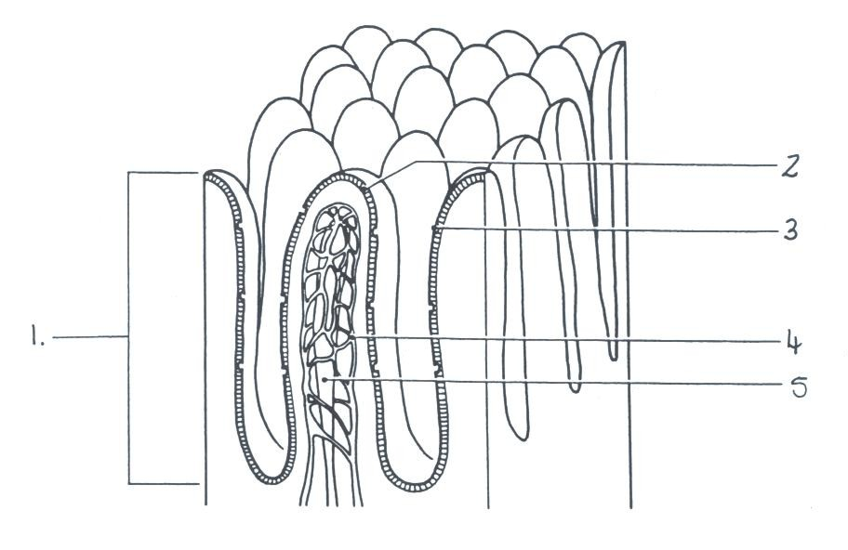

1. Name each of the following structures and explain how they aid in the process of

absorption.

1.___________________________________________________________________________

_____________________________________________________________________________

_____________________________________________________________________________

4.___________________________________________________________________________

_____________________________________________________________________________

_____________________________________________________________________________

5.___________________________________________________________________________

_____________________________________________________________________________

_____________________________________________________________________________

(6 marks)

b) Give one other way in which the structures shown in the diagram are particularly well suited to their function of absorption of food.

____________________________________________________________________________

_____________________________________________________________________________

(1 mark)

**END OF SECTION B**